BACCALAURÉAT GÉNÉRAL ET TECHNOLOGIQUE
ÉPREUVE ORALE DES SECTIONS EUROPÉENNES ET DE LANGUES ORIENTALES

DNL : Physique Chimie |  | Toute Spécialité
Langue : Anglais |  | Voie générale
THEME : La Terre, son climat, ses changements
SOUS-THEME : L’atmosphère terrestre | NOTION : 1.1.3 Cycle du carbone

Breathing fire : On hot coals at Jharia coal fields

Document 1 Document 2

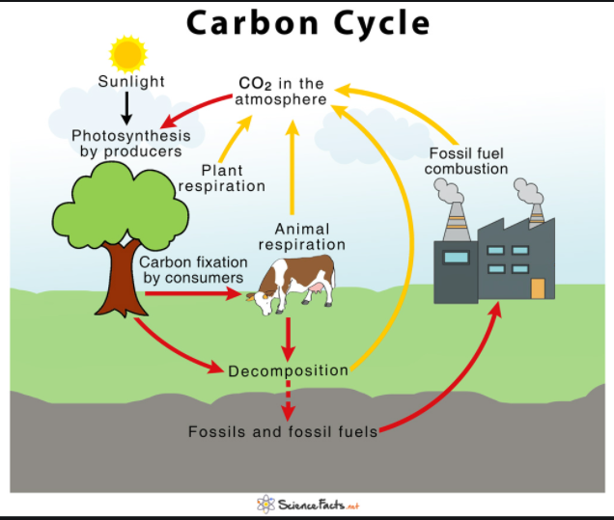
Jharia coalfield is a large coal field located in the east of India in Jharia, Jharkhand. Jharia represents the largest coal reserves in India having estimated reserves of 19.4 billion tonnes of coking coal. The coalfield is an important contributor to the local economy, employing much of the local population either directly or indirectly.
https://en.wikipedia.org/wiki/Jharia_coalfield

Document 3
Mohmmed Usman Ansari, 55, is a worried man. The smoke that billows from fissures on the ground, 10 metres from his house near Lodna village in Jharkhand’s Jharia coalfields, is a warning sign: that he must move home. The century-old underground coal burning could reduce his home to rubble.
“My forefathers worked here as contractors. Four generations have lived on this land beneath which coal has burned constantly,” says Ansari. Homes are frequently lost, and the real health hazard that these coalfields pose has left his family concerned.
Since the first coal fire, reported in 1916 as a result of unscientific mining carried out by former mine owners in Jharia, fires have broken out in underground workings and opencast pits and debris. Traffic on National Highway 32 was once affected by fire in the Kenduadih colliery in Jharia. Trains were diverted when tracks were impacted by underground coal burning.
Ansari says 70,011 households had to be resettled along the fringes of Jharia.
The National Remote Sensing Centre, Hyderabad, said that surface fire had expanded from 2.018 sq. km* in 2014 to 3.28 sq. km in 2018.
Company sources say that after nationalisation, 70 fires were reported over an area of 17.32 sq. km. An estimated 37 million tonnes of prime coking coal have been destroyed and about 1,864 tonnes of coal remain inaccessible behind the fires.
https://www.thehindu.com/news/national/other-states/breathing-fire-on-hot-coals-at-jharia-coal-fields/article30479245.ece/photo/7/
*sq.km : square kilometer
- Present and comment on this document.
- Focus on a scientific topic such as the impact of coal fields on our planet and the carbon cycle .
- Can you imagine a solution to clean the air in Jharia ?

