BACCALAURÉAT GÉNÉRAL ET TECHNOLOGIQUE
ÉPREUVE ORALE DES SECTIONS EUROPÉENNES ET DE LANGUES ORIENTALES

DNL : Physique-Chimie |  | Toute spécialité
Langue : Anglais |  | Voie générale
THEME : La Terre, son climat, ses changements
SOUS-THEME : La complexité du système climatique et ses changements | NOTION : 1.2.2 Comprendre le changement climatique

NITROUS OXIDE AND CLIMATE CHANGE

DOCUMENT 1: Nitrogen fertilisers are incredibly efficient, but they make climate change a lot worse
Nitrous oxide (N₂O) (more commonly known as laughing gas) is a powerful contributor to global warming. It is 265 times more effective at trapping heat in the atmosphere than carbon dioxide and depletes our ozone layer.
There are a number of natural and human sources of N₂O emissions, which have remained relatively steady for millennia. However, in the early 20th century the Haber-Bosch process was developed, allowing industry to chemically synthesize molecular nitrogen from the atmosphere to create nitrogen fertilizer. This advancement kick-started the Green Revolution, one of the greatest and fastest human revolutions of our time. Crop yields* across the world have increased many times over due to the use of nitrogen fertilizers and other improved farming practices. But when soil is exposed to abundant nitrogen in its active form (as in fertilizer), microbial reactions take place that release N₂O emissions. The unrestricted use in nitrogen fertilizers, therefore, created a huge uptick in emissions. N₂O is the third-most-important greenhouse gas after carbon dioxide and methane. As well as trapping heat, it depletes ozone in the stratosphere, contributing to the ozone hole. Once released into the atmosphere, N₂O remains active for more than 100 years.
DOCUMENT 2: Where does N₂O come from?
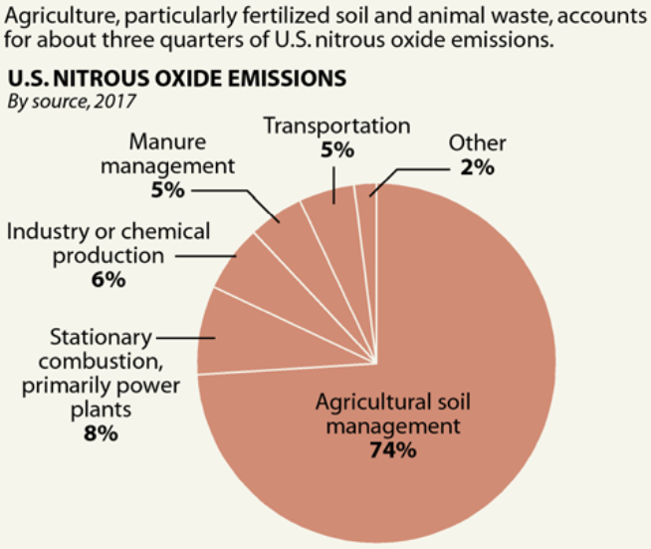
from EPA (Environmental Protection Agency of U.S.)

by Pep Canadell, Hanqin Tian, Prabir Patra and Rona Thompson
https://theconversation.com/, November 18, 2019
* crop yield = rendement

1. Present and comment on this document.
2. Focus on at least one scientific topic such as the greenhouse effect.
3. In everyday life, what can people do to limit global warming?

