BACCALAURÉAT GÉNÉRAL ET TECHNOLOGIQUE
ÉPREUVE ORALE DES SECTIONS EUROPÉENNES ET DE LANGUES ORIENTALES

DNL : Physique Chimie |  | Toute Spécialité
Langue : Anglais |  | Voie générale
THEME : Physique et chimie au service de la société du futur
SOUS-THEME : Les ondes au service du citoyen | NOTION : 3.1.1.Ondes électromagnétiques

BLUETOOTH
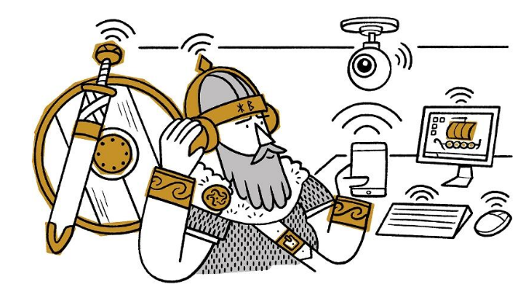
Bluetooth is a wireless system for connecting devices together such as computers and mobile phones when they are close to each other. A Bluetooth network allows them to exchange data.
Bluetooth is named after Harald “Bluetooth” Gormsson, a Danish king in the 10th century who united warring tribes. The Bluetooth logo is based on the symbols he used for his initials.

How does Bluetooth work?
You may have used Bluetooth, for example, to connect a mobile phone to a speaker or to headphones. In this case the phone is known as the ‘main unit’ and the speaker or headphones are known as ‘peripheral’. Connecting the devices is called ‘pairing’.
Devices connected in a Bluetooth network communicate with each other using ultra-high frequency (UHF) radio waves. These are electromagnetic waves with frequencies around 2.4 gigahertz (2.4 billion waves per second).
UHF waves of different frequencies are used in microwave ovens, GPS systems and many other devices.

Uses
- Much like headphones and earbuds, hearing aids can take advantage of Bluetooth technology. Hearing aids do not use wires to connect to anything : a wearer can connect their hearing aids directly to their cell phones.
- This advance in hearing aids has improved the user experience when it comes to making cell phone calls. Rather than having to listen to the call through the cell phone and then through the hearing aid, the audio is piped into the ear through the hearing aid.
- Other medical uses include monitoring systems in prosthetics, internal and external monitors, and insulin pumps. By connecting through Bluetooth, the medical device can talk to apps on a smartphone or other devices. This enables the doctor or patient monitor and diagnose problems in real-time.
https://www.iop.org/explore-physics/technology-our-lives/bluetooth

- Present and comment on the document.
- What are the properties about electromagnetic waves ?
- How can Bluetooth change our life ?

