BACCALAURÉAT GÉNÉRAL ET TECHNOLOGIQUE
ÉPREUVE ORALE DES SECTIONS EUROPÉENNES ET DE LANGUES ORIENTALES
DNL : Physique chimie |  | Toute Spécialité
Langue : Anglais |  | Voie générale
THEME : Physique et chimie au service de la société du futur
SOUS-THEME : Vers une chimie durable | NOTION : 3.3.3 Vers une eau plus propre

MICROPLASTICS IN WATER
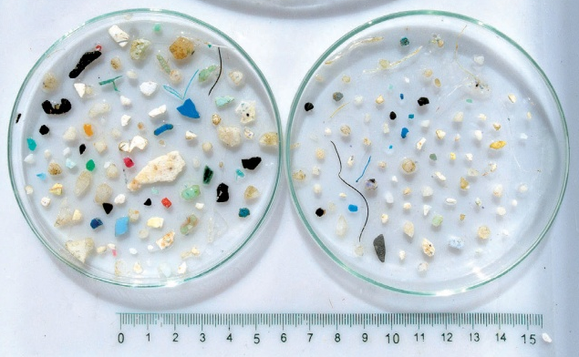
DOCUMENT 1: What are microplastics?
Plastic is the most prevalent type of marine debris found in our ocean. Plastic debris can come in all shapes and sizes, but those that are less than five millimeters in length are called “microplastics.” […] Microplastics come from a variety of sources, including from larger plastic debris that degrades into smaller and smaller pieces. These particles easily pass through water filtration systems and end up in the ocean, posing a potential threat to aquatic life and birds, which can mistake them for food.
As an emerging field of study, not a lot is known about microplastics and their impacts yet. In 2015, the U.S. banned the use of microbeads (microplastics intentionally added to some manufactured health and beauty products). But microplastics are still a huge problem. You can help keep plastic out of the ocean. Remember: Reduce. Reuse. Recycle.
(National Oceanic and Atmospheric Administration (NOAA), https://oceanservice.noaa.gov/facts/microplastics.html, 02/26/21)
DOCUMENT 2: World Health Organization (WHO) information sheet about microplastics in drinking water
Microplastics are ubiquitous* in the environment and have been detected in a broad range of concentrations in marine water, wastewater, fresh water and drinking-water, both bottled and tap water. […] Limited evidence suggests that key sources of microplastic pollution in fresh water sources are terrestrial run-off and wastewater effluent**. However, optimized wastewater (and drinking-water) treatment can effectively remove most microplastics from the effluent.
(WHO, https://www.who.int/water_sanitation_health/water-quality/guidelines/microplastics-in-dw-Information-sheet.pdf?ua=1, 2019)
* ubiquitous: omnipresent
** effluent: discharge
1. Present and comment on this document.
2. Focus on at least one scientific topic such as water pollution analysis or water treatment.
3. Could it be possible to reconcile the use of plastics and water quality?

