**BACCALAURÉAT GÉNÉRAL ET TECHNOLOGIQUE**

**ÉPREUVE ORALE DES SECTIONS EUROPÉENNES ET DE LANGUES ORIENTALES**

|  |  |
| --- | --- |
| **DNL :** Physique-chimie | Toutes spécialités |
| **Langue :** Anglais | Voie Générale |
| THEME 3 : Physique et chimie au service de la société du futur | |
| SOUS-THEME : L’exploration spatiale | NOTION : **3.2.2 Satellites et Sondes** |

**INTERNATIONAL SPACE STATION**

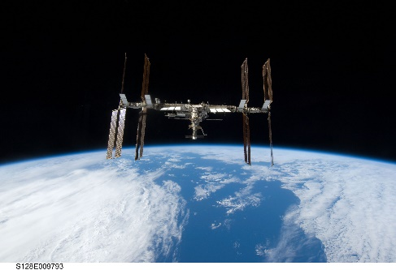**DOCUMENT 1**

In partnership with the United States, Russia, Japan and Canada, Europe is sharing in the greatest international project of all time - the International Space Station (ISS). The 420-tonne International Space Station has more than 916 cubic metres of pressurised space - enough room for its crew of six people and a vast array of scientific experiments.

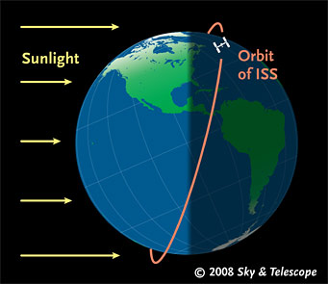*(ESA)*

**DOCUMENT 2: Trajectory of the ISS**

The International Space Station with ESA’s Columbus laboratory flies 400 km high. It only takes 92 minutes for the weightless laboratory to make a complete circuit of Earth. Astronauts working and living on the Station experience 16 sunrises and sunsets each day.

Data: orbital inclination: 51.63°

*(*ESA*)*

**DOCUMENT 3: Comparison LEO/GEO Earth satellites**

The close proximity of LEO (Low Earth Orbit) to Earth makes it useful for several reasons. It is the orbit most commonly used for satellite imaging, as being near the surface allows it to take images of higher resolution. It is also the orbit used for the International Space Station (ISS), as it is easier for astronauts to travel to and from it at a shorter distance. Satellites in this orbit travel at a speed of around 7.8 km per second.

Satellites in geostationary orbit (GEO) circle Earth above the equator from west to east following Earth’s rotation – taking 23 hours 56 minutes and 4 seconds – by travelling at exactly the same rate as Earth. This makes satellites in GEO appear to be ‘stationary’ over a fixed position. In order to perfectly match Earth’s rotation, the speed of GEO satellites should be about 3 km per second at an altitude of 35 786 km.

*(*ESA*)*

1. Present and comment on this document.

2. Do not forget to focus on at least one scientific topic such as trajectories, speed and/or gravitation.

3. What do you think of space exploration?