**BACCALAURÉAT GÉNÉRAL ET TECHNOLOGIQUE**

**ÉPREUVE ORALE DES SECTIONS EUROPÉENNES ET DE LANGUES ORIENTALES**

|  |  |  |
| --- | --- | --- |
| **DNL :** Physique Chimie | | Toutes Spécialités |
| **Langue :** Anglais | | Voie générale |
| THEME 1: La Terre, son climat, ses changements | | |
| SOUS-THEME : L'atmosphère terrestre | NOTION : **1.1.1 Composition de l'atmosphère, originelle et actuelle** | |

[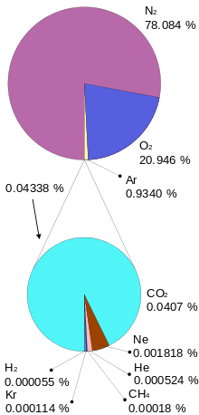](https://en.wikipedia.org/wiki/File:Atmosphere_gas_proportions.svg)

**ATMOSPHERE OF EARTH**

**DOCUMENT 1**

The **atmosphere of Earth**, commonly known as **air**, is the layer of [gases](https://en.wikipedia.org/wiki/Gas) retained by [Earth's gravity](https://en.wikipedia.org/wiki/Earth%27s_gravity) that surrounds the planet and forms its planetary [atmosphere](https://en.wikipedia.org/wiki/Atmosphere). The atmosphere of Earth protects [life](https://en.wikipedia.org/wiki/Life) on Earth by creating [pressure](https://en.wikipedia.org/wiki/Atmospheric_pressure) allowing for [liquid water](https://en.wikipedia.org/wiki/Liquid_water) to exist on the Earth's [surface](https://en.wikipedia.org/wiki/Planetary_surface), absorbing [ultraviolet](https://en.wikipedia.org/wiki/Ultraviolet) [solar radiation](https://en.wikipedia.org/wiki/Solar_radiation), warming the surface through heat retention ([greenhouse effect](https://en.wikipedia.org/wiki/Greenhouse_effect)), and reducing temperature extremes between [day](https://en.wikipedia.org/wiki/Daytime) and [night](https://en.wikipedia.org/wiki/Night) (the [diurnal temperature variation](https://en.wikipedia.org/wiki/Diurnal_temperature_variation)).

*From Wikipédia-https://en.wikipedia.org/wiki/Atmosphere_of_Earth-2022*

**DOCUMENT 2**

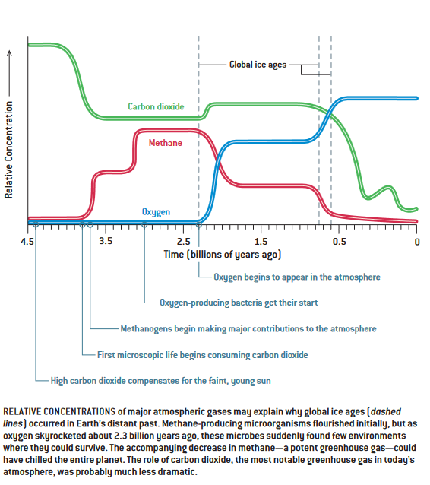Earth's early atmosphere consisted of gases in the [solar nebula](https://en.wikipedia.org/wiki/Solar_nebula), primarily hydrogen. The atmosphere changed significantly over time, affected by many factors such as [volcanism](https://en.wikipedia.org/wiki/Volcanism), [life](https://en.wikipedia.org/wiki/Life), and [weathering](https://en.wikipedia.org/wiki/Weathering). Recently, human activity has also contributed to [atmospheric changes](https://en.wikipedia.org/wiki/Human_impact_on_the_environment#Impacts_on_Climate), such as [global warming](https://en.wikipedia.org/wiki/Global_warming), [ozone depletion](https://en.wikipedia.org/wiki/Ozone_depletion) and [acid deposition](https://en.wikipedia.org/wiki/Acid_deposition).

From Wikipédia https://en.wikipedia.org/wiki/ Atmosphere _ of_Earth-2022 and from Scientici american-J Kasting *https://www.mr.is/~gk/hs/pdf/throun_gufuhvolfs_jardar0407.pdf- 2004*

1. Present and comment on this document

2. Do not forget to focus on at least one scientific topic such as greenhouse effect and its major contributors

3. According to you, what can humans do to fight climate change?