**BACCALAURÉAT GÉNÉRAL ET TECHNOLOGIQUE**

**ÉPREUVE ORALE DES SECTIONS EUROPÉENNES ET DE LANGUES ORIENTALES**

|  |  |
| --- | --- |
| **DNL :** physique-chimie | Toutes spécialités |
| **Langue :** Anglais | Voie générale |
| THEME 1: La Terre, son climat, ses changements | |
| SOUS-THEME : L’atmosphère terrestre | NOTION : **1.1.2 Phénomènes dans l’atmosphère** |

**OZONE: FRIEND OR ENEMY?**

**DOCUMENT 1: What is ozone and where is it in the atmosphere?**

**DOCUMENT 2: Stratospheric ozone production**

https://csl.noaa.gov/

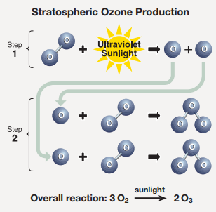Ozone ($O_{3}$) is a highly reactive gas. It is both a natural and a man-made product that occurs in the Earth's upper atmosphere (the stratosphere) and lower atmosphere (the troposphere).  Depending on where it is in the atmosphere, ozone affects life on Earth in either good or bad ways.

Tropospheric or ground-level ozone – what we breathe – is formed primarily from photochemical reactions between two major classes of air pollutants, volatile organic compounds (VOC) and nitrogen oxides ($NO_{x}$).  These reactions have traditionally been viewed as depending upon the presence of heat and sunlight. […] Ozone contributes to what we typically experience as "smog" or haze […]

Although some stratospheric ozone is transported into the troposphere, and some VOC and $NO_{x}$ occur naturally, the majority of ground-level ozone is the result of reactions of man-made VOC and $NO_{x}$. Significant sources of VOC are chemical plants, gasoline pumps, oil-based paints, autobody shops, and print shops. Nitrogen oxides result primarily from high temperature combustion. Significant sources are power plants, industrial furnaces and boilers, and motor vehicles.

United States Environmental Protection Agency, https://www.epa.gov

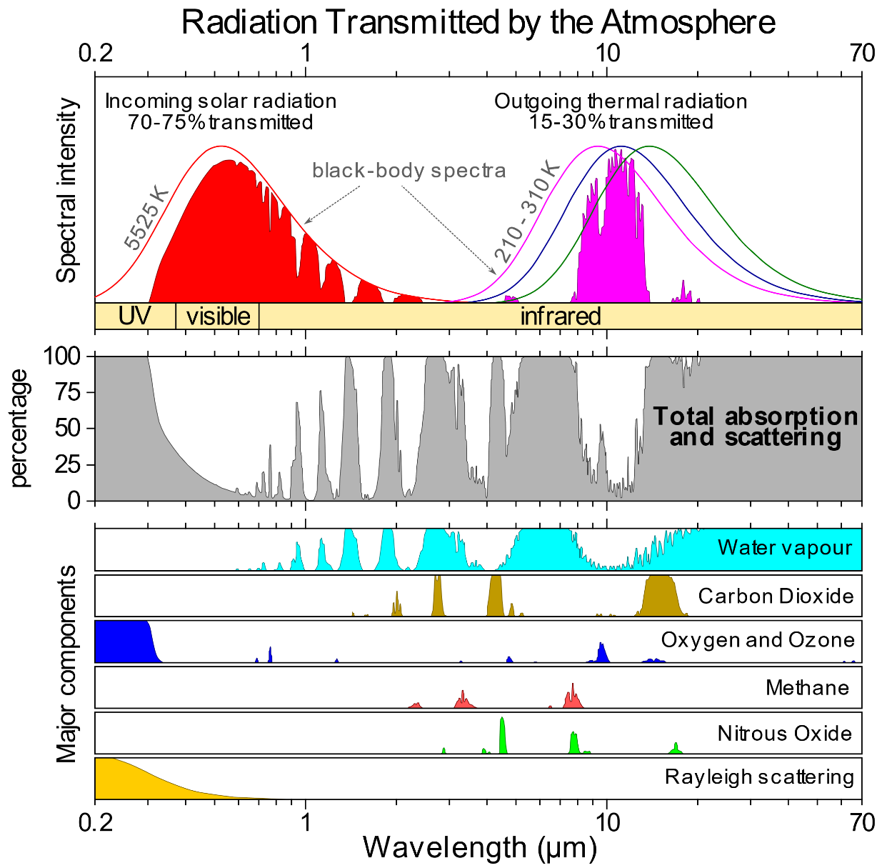**DOCUMENT 2: The positive impact of Ozone on UV**

1. Present and comment on these documents.

2. Do not forget to focus on at least one scientific topic.

3. How do human activities affect our health and the climate?