**BACCALAURÉAT GÉNÉRAL ET TECHNOLOGIQUE**

**ÉPREUVE ORALE DES SECTIONS EUROPÉENNES ET DE LANGUES ORIENTALES**

|  |  |
| --- | --- |
| **DNL :** physique Chimie | Toutes spécialités |
| **Langue :** Anglais | Voie générale |
| THEME 1:La Terre, son climat, ses changements | |
| SOUS-THEME : La complexité du système climatique et ses changements | NOTION : **1.2.1 Observer la Terre** |

**Global Temperatures and CO2 Concentrations (***February 19th, 2020)*

[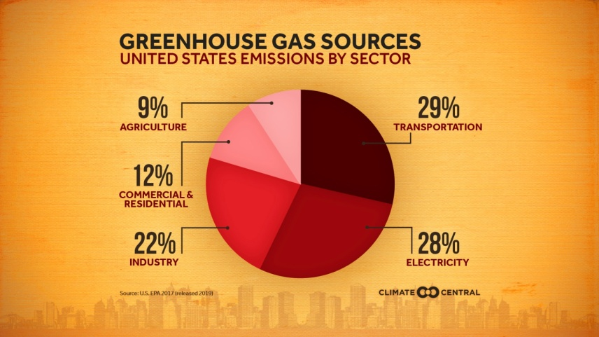](https://ccimgs-2020.s3.amazonaws.com/2020Drawdown/2020Drawdown_Sources_en_title_lg.jpg)According to NOAA, January 2020 was the hottest January on record globally. This record is one data point in a global trend of warming—one that is directly related to human emissions of greenhouse gases. Stabilizing our climate will require substantially reducing our emissions - and understanding where they’re coming from is a key part of the process.

As defined by the Environmental Protection Agency (EPA), U.S. greenhouse gas emissions sources can be broken down into five sectors

Transportation is currently the largest source of greenhouse gas emissions in the U.S., having surpassed electricity generation in 2016. Emissions are produced through the burning of petroleum in the internal combustion engines of everything from cars and trucks to trains, planes and ships.

Emissions from the electricity sector almost exclusively come from the combustion of fossil fuels to generate electricity.

[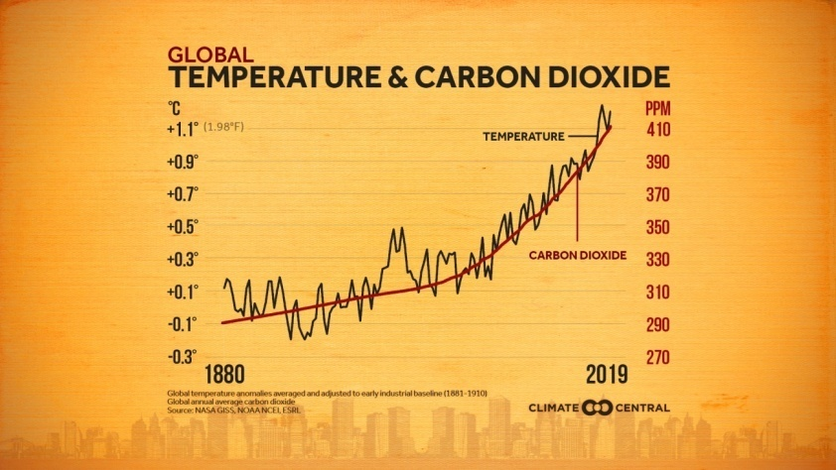](https://ccimgs-2020.s3.amazonaws.com/2020Drawdown/2020Drawdown_TempCO2_en_title_lg.jpg)Renewable energy sources—such as solar, wind, and hydroelectric—accounted for 16% of energy generation, while the remainder was generated by nuclear power and non-coal fossil fuels—natural gas and petroleum. This is a sector that is changing rapidly. According to a recent estimate, the share of electricity generated by renewables is currently expected to roughly double from 19% in 2019 to 38% in 2050…

…Now at 414 ppm, atmospheric CO2 concentrations are higher than at any time in the past 800,000 years, which directly relates to the planet's temperature. The world has committed to keep warming well below 2℃ globally, and that comes with the challenge of a carbon budget—a low-carb diet, if you will. Scientists estimate that humans can only emit 565 more gigatons of carbon dioxide and reasonably hope to meet the 2℃ target—a budget that would be exhausted in 15 years if emissions continue at the current rate of 36.6 gigatons of CO2 a year.

*(https://www.climatecentral.org/gallery/graphics/global-temperatures-and-co2-concentrations-2020)*

1. Present and comment on this document.

2. Focus on at least one scientific topic such as the impact greenhouse effect consequence of human action on the increasing greenhouse effect.

3. Do you know any other phenomenon or clue that point out the Earth Global Warming?