**BACCALAURÉAT GÉNÉRAL ET TECHNOLOGIQUE**

**ÉPREUVE ORALE DES SECTIONS EUROPÉENNES ET DE LANGUES ORIENTALES**

|  |  |  |
| --- | --- | --- |
| **DNL :** Physique-chimie | | Toutes Spécialités |
| **Langue :** Anglais | | Voie générale |
| THEME 1 : La Terre, son climat, ses changements | | |
| SOUS-THEME : La complexité du système climatique et ses changements | NOTION : **1.2.2 Comprendre le changement climatique** | |

**TROPICAL DAMS: AN UNDERESTIMATED SOURCE OF GREENHOUSE GAS EMISSIONS**

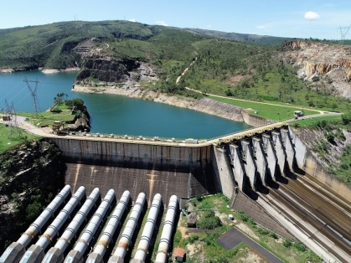Hydropower dams are rising on rivers in tropical regions, and their energy is promoted as vital to their economic development. In Brazil, for example, hydroelectric plants (some of them located in the Amazon) [produce around 75 % of the country’s energy](https://www.eia.gov/todayinenergy/detail.php?id=16731). Facing increasing demand for renewable electricity, the country’s hydroelectric generation capacity is projected to expand to 112 GW by 2024. Beyond the current boom, tropical dams and hydropower are an underappreciated suite of players in global warming as the water reservoirs behind them release large quantities of methane. Although it remains in the atmosphere for only a few years, [methane is 28 times more powerful than CO2](https://ec.europa.eu/energy/topics/oil-gas-and-coal/methane-gas-emissions_en) at trapping the Sun’s heat. […]

The EU-funded HYDROCARB project was established to assess the real greenhouse gas footprints of tropical reservoirs. Funded through the European Research Council, HYDROCARB is different from previous studies in that it investigates not only carbon emissions, but also carbon storage in trapped sediments that have so far been largely overlooked in the greenhouse gas debate.[…]

Tropical reservoirs can act as ‘methane factories’, removing CO2 from the atmosphere and returning it as methane with a much greater impact on the environment. Water plants, phytoplankton and algae take up and bind CO2 as they grow, but when they die, they sink to the bottom where they are digested by methane-producing microbes in the sediment. […] Researchers concluded that by curbing the supply of nutrients to rivers and reservoirs, for example through treating sewage water or better managing fertilizer use, water plants and phytoplankton would grow less and thus supply less food to the methane-producing microbes. “Overall, the study shows that tropical dams as a renewable energy source do not come without their greenhouse gas costs. Preliminary data show that although trapped sediment can act as a carbon sink, in no case can it outweigh the large amounts of methane released,” concludes project coordinator Sebastian Sobek.

*From https://cordis.europa.eu/, European research council, June 2nd, 2020*

By curbing: en limitant

To outweigh: compenser

1. Present and comment on this document.

2. Remember to ask yourself how greenhouse effect works and why greenhouse gases from tropical dams contribute so much to global warming?

3. Do you think there is another way to produce renewable electricity at a lower environmental cost in respect to global warming?