BACCALAURÉAT GÉNÉRAL ET TECHNOLOGIQUE
ÉPREUVE ORALE DES SECTIONS EUROPÉENNES ET DE LANGUES ORIENTALES

DNL : Physique Chimie | Toutes Spécialités
Langue : ANGLAIS | Voie générale
THEME 2: Le futur des énergies
SOUS-THEME : Deux siècles d’énergie électrique | NOTION : 2.1.2 Evolution de la notion d’énergie

EINSTEIN’S LEGACY : THE PHOTOELECTRIC EFFECT
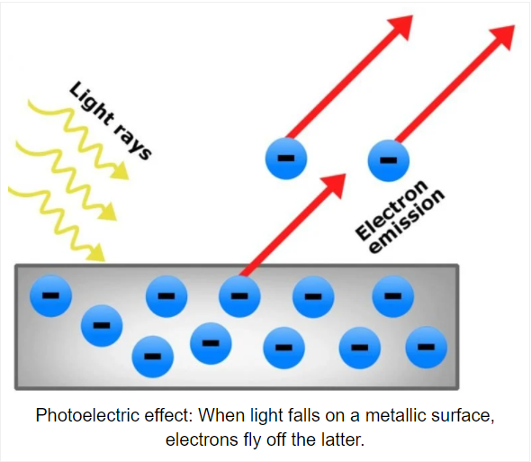
Despite the popularity of Einstein's theories of relativity [..], Einstein's Nobel Prize in physics (1921) was actually awarded for his discovery of the photoelectric effect. This discovery revolutionized our understanding of the world around us.

What Is the Photoelectric Effect?
When light with energy above a certain threshold hits a metal surface, an electron that was previously bound to the metal is knocked loose. Each particle of light, called a photon, collides with an electron and uses some of its energy to dislodge it from the metal. The rest of the photon’s energy is transferred to the now free-roaming negative charge, called a photoelectron. [..]
Figure 1: issue de scienceabc.com
In 1905, Einstein reported that all of the observed phenomena could be explained if light was thought of as a stream of particles (or quanta of light called photons) rather than as a wave. [..]
Where Would We Be Without the Photoelectric Effect?
The photoelectric effect has direct applications in the use of photocells and solar cells where energy is produced due to incident photons. More importantly, however, the photoelectric effect set off the quantum revolution. Experimental physicists began to think about the nature of light and the structure of atoms, the foundation of the world around us, in an entirely new way.
https://www.quickanddirtytips.com/education/science/einsteins-legacy-the-photoelectric-effect?page=1

1. Present and comment on this document.
2. Focus on at least one scientific topic such as the electricity generation.
3. In your opinion, what are the environmental challenges of researching new ways of generating electricity?

