**BACCALAURÉAT GÉNÉRAL ET TECHNOLOGIQUE ÉPREUVE ORALE DES SECTIONS EUROPÉENNES ET DE LANGUES ORIENTALES**

Electricity to consumers

Turbine electric generator

Kinetic energy source

|  |  |  |
| --- | --- | --- |
| **DNL :** physique chimie | | **Toutes Spécialités** |
| **Langue :** Anglaise | | Voie générale |
| THEME 2: Le futur des énergies | | |
| SOUS-THEME : Les atouts de l’électricité | NOTION : **2.2.1 Produire de l’énergie électrique** | |

**THE WORLD’S BIGGEST HYDRO ELECTRIC POWER PLANT**

**DOCUMENT 1 : The three Gorges Dam*(1)***

Built on the Yangtze River in the Hubei Province of central China, in 2012, the Three Gorges Dam took over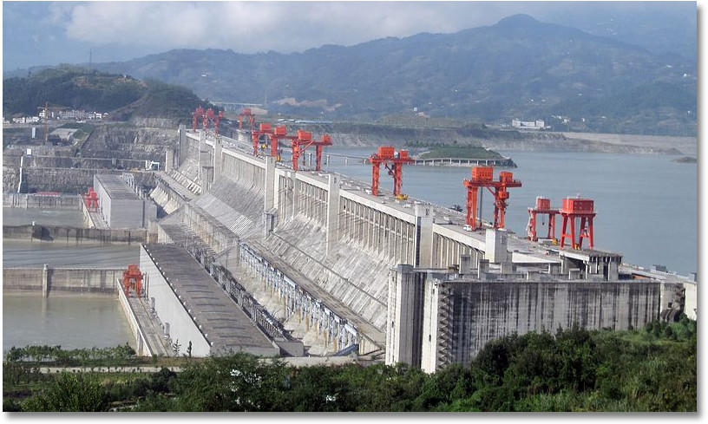 the number 1 spot of the largest hydroelectric dam in electricity production in the world. The 2.3 km-long concrete gravity dam is designed to control massive floods of the Yangtze River by diverting them downstream. Equipped with 34 generators, the power plant has an installed capacity of 22.5 gigawatts (GW) compared to the most powerful (1.8 GW) hydropower plant of Grand’Maison in France.

*The Three Gorges Dam -https://www.usgs.gov*

*Adapted from www.usgs.gov and www.power-technology.com (2021)*

**DOCUMENT 2 : Electricity generation from an electric turbine**

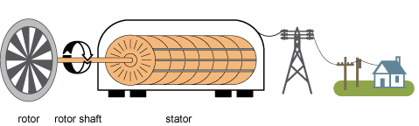

An electric generator is a device that converts a form of energy into electricity. There are many different types of electricity generators. Most of world electricity generation is from generators that are based on scientist Michael Faraday’s discovery in 1831.

Moving a magnet inside a coil*(2)* of wire makes (induces) an electric current to flow in the wire.

He made the first electricity generator called a Faraday disk, which operates on this relationship between magnetism and electricity and which led to the design of the electromagnetic generators that we use today.

*https://www.eia.gov/energyexplained- November 1, 2021*

*(1)* *barrage (2)* *bobine*

1. Present and comment on this document.

2. Do not forget to focus on at least one scientific topic such as the different sources of kinetic energy of a power plant and the energy transfers that occur in.

3. Do you think the Three Gorges Dam is an ecological project that we should develop wherever possible throughout the world ?