**BACCALAURÉAT GÉNÉRAL ET TECHNOLOGIQUE**

**ÉPREUVE ORALE DES SECTIONS EUROPÉENNES ET DE LANGUES ORIENTALES**

|  |  |
| --- | --- |
| **DNL :** physique-chimie | Toutes spécialités |
| **Langue :** ANGLAIS | Voie générale |
| THEME : Le futur des énergies | |
| SOUS-THEME : Les atouts de l’électricité | NOTION : **2.2.2** **Décrire une ou deux chaînes de transformations énergétiques** |

**ENERGY EFFICIENCY**

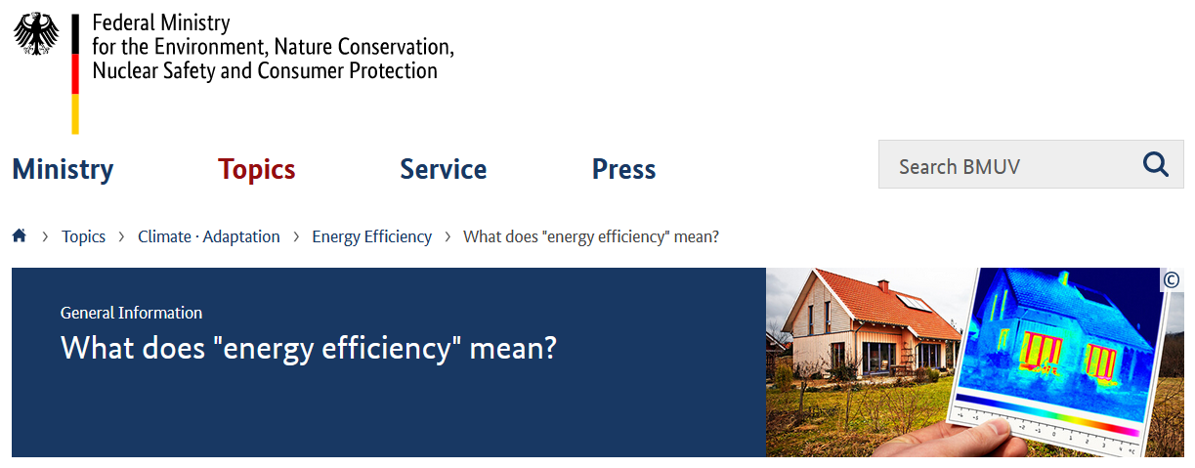

**What does "energy efficiency" mean?**

A warm living room in winter or a sports stadium brightly illuminated at night – we use energy to achieve a specific benefit. Energy efficiency is a means of measuring the energy-expenditure required to achieve a certain benefit. The lower the losses in energy to achieve a specific purpose are, the higher is the degree of energy efficiency.

**Why do we need more energy efficiency?**

Energy demand is increasing worldwide. The energy market situation is heating up and energy prices are on the rise. Instabilities in many exporting and transit countries are a cause for concern and the increased combustion of fossil energy sources is accelerating climate change. An expansion of energy supply options is costly and will take time. On the other hand, increasing energy efficiency curbs energy prices, reduces dependency on energy imports, counteracts energy distribution conflicts and cuts climate-damaging carbon dioxide emissions.

*Source:* [*https://www.bmuv.de/en/topics/climate-adaptation/energy-efficiency/what-does-energy-efficiency-mean#c10244*](https://www.bmuv.de/en/topics/climate-adaptation/energy-efficiency/what-does-energy-efficiency-mean#c10244)*; 2022-02-18*

1. Present and comment on this document.

2. Focus on at least one scientific topic such as the energy chain of an electric device that you may use on a daily basis, e.g. a toaster, a lightbulb, a kettle… and their efficiency.

3. Why is it important to be aware of the energy efficiency of your electric devices?