**BACCALAURÉAT GÉNÉRAL ET TECHNOLOGIQUE**

**ÉPREUVE ORALE DES SECTIONS EUROPÉENNES ET DE LANGUES ORIENTALES**

|  |  |
| --- | --- |
| **DNL :** physique-chimie | Toutes spécialités |
| **Langue :** Anglais | Voie générale |
| THEME 2 : Le futur des énergies | |
| SOUS-THEME : Les atouts de l’électricité | NOTION : ***2.2.2. Décrire une ou deux chaînes de transformations énergétiques*** |

**HOW BIG ARE POWER LINE LOSSES?**

**DOCUMENT 1: Electricity networks**

**DOCUMENT 2: Transport and distribution of electrical energy**

The power system has three levels:

- The main transmission system and interconnectors (400 kV or 225 kV)

- The regional subtransmission networks (225 kV, 90 kV and 63 kV)

- The 20 kV and 400 V distribution networks, which supply electricity to end consumers.

The network serves interconnectors with neighbouring countries, large generation facilities (nuclear, hydro-electric and thermal plants), as well as the subtransmission networks. They also collect the energy generated by intermediate-sized power plants.

In France, RTE (Réseau du Transport d’Electricité) owns and operates the public electricity transmission network, which runs for a total length of around 100,000 kilometres.

Source: Commission de régulation de l’énergie en France ; June *2018*

Source: Museum in Macao, China - 12/2022

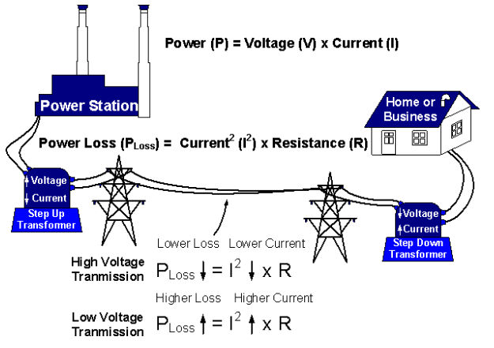

**DOCUMENT 3: Energy flows in the global electricity system (TWh)**

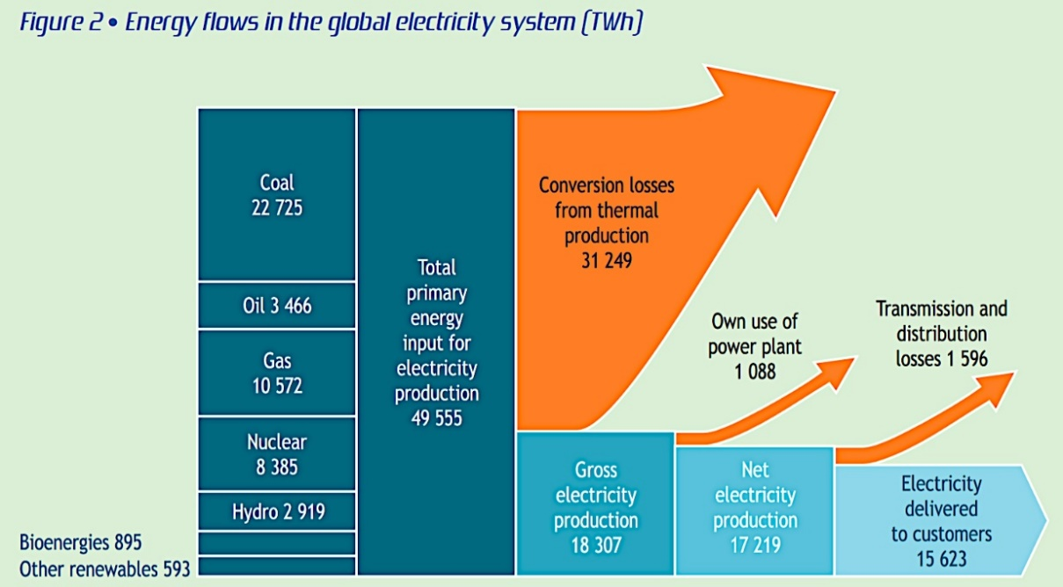

Source: from International Energy Agency, October 2021

**Questions:**

1. Present and comment on these documents.

2. Focus on a scientific topic and explain the losses of energy on high voltage lines.

3. To what extent has energy production and consumption become a challenge?