**BACCALAURÉAT GÉNÉRAL ET TECHNOLOGIQUE**

**ÉPREUVE ORALE DES SECTIONS EUROPÉENNES ET DE LANGUES ORIENTALES**

|  |  |
| --- | --- |
| **DNL :** physique-chimie | **Toutes spécialités** |
| **Langue :** Anglais | Voie générale |
| THEME 2 : LE FUTUR DES ENERGIES | |
| SOUS-THEME : Les atouts de l’électricité | NOTION : ***2.2.2. Décrire une ou deux chaînes de transformations énergétiques*** |

**HOW BIG ARE POWER LINE LOSSES?**

**DOCUMENT 2: Transport and distribution of electrical energy**

**DOCUMENT 1: Electricity networks**

The power system has three levels:

- The main transmission system and interconnectors (400 kV or 225 kV)

- The regional subtransmission networks (225 kV, 90 kV and 63 kV)

- The 20 kV and 400 V distribution networks, which supply electricity to end consumers.

The network serves interconnectors with neighbouring countries, large generation facilities (nuclear, hydro-electric and thermal plants), as well as the subtransmission networks. They also collect the energy generated by intermediate-sized power plants.

In France, RTE (Réseau du Transport d’Electricité) owns and operates the public electricity transmission network, which runs for a total length of around 100,000 kilometres.

*(https://www.cre.fr/en/Electricity/ June 2018)*

*http://www.cmm.gov.*

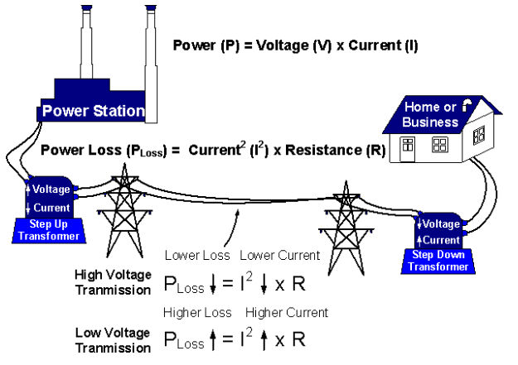

**DOCUMENT 3: Energy flows in the global electricity system (TWh)**

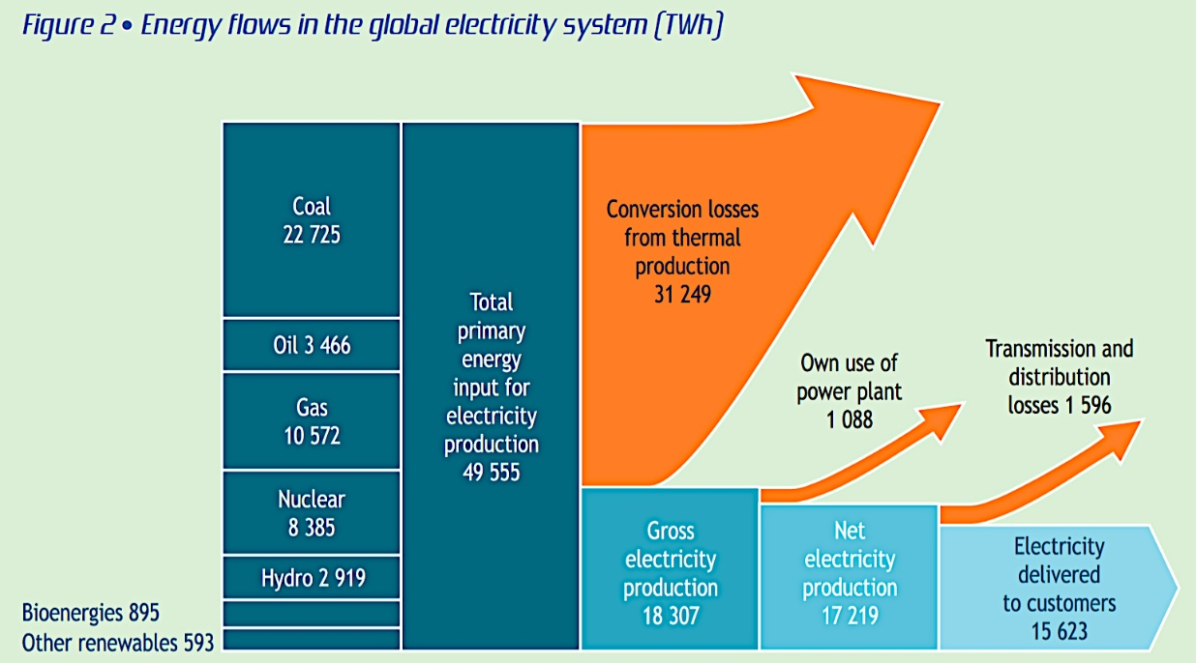

(From International Energy Agency, October 2021)

1. Present and comment on these documents.

2. Do not forget to focus on at least one scientific topic.

3. To what extent has energy production and consumption become a challenge?