**BACCALAURÉAT GÉNÉRAL ET TECHNOLOGIQUE**

**ÉPREUVE ORALE DES SECTIONS EUROPÉENNES ET DE LANGUES ORIENTALES**

|  |  |
| --- | --- |
| **DNL :** Physique chimie | Toutes Spécialités |
| **Langue :** Anglais | Voie générale |
| THEME 2 : Le futur des énergies | |
| SOUS-THEME : Les atouts de l’électricité | NOTION : **2.2.3 Nécessité de stockage** |

**CONVERTING RENEWABLE POWER SURPLUS INTO GASES**

The **Jupiter 1000** project, launched in 2014, is the first industrial demonstrator of Power to Gas with a power rating of 1 MWe (MegaWatt Electrical) for electrolysis and a methanation process with carbon capture. Green hydrogen will be produced using two electrolysers involving different technologies, from 100% renewable energy. The installation will be based on an innovative methanation technology and CO2 will be captured on a nearby industrial site (Fos-sur-mer, France). Over the longer term, the idea is to launch the Power to Gas activity in France. More than 15 TWh of gas could be produced each year using the Power to Gas system by 2050. The Jupiter 1000 project is partly financed by the European Union.

The reactions involved in this process are:

a) 2 H2O(l) O2(g) + 2 H2(g) *(electrolysis)*

b) CO2(g) + 4 H2(g) CH4(g) + 2 H2O(g)

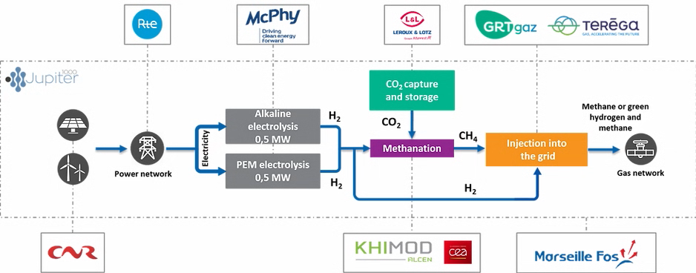

*PEM : Proton Exchange Membrane

*https://www.jupiter1000.eu/english - 2021*

1. Present and comment on this document.

2. Describe electricity storage issues, and find the scientific pros and cons of producing and using gases such as H2 and CH4.

3. Do you know other innovating systems to fight the surplus of greenhouse gases?