**BACCALAURÉAT GÉNÉRAL ET TECHNOLOGIQUE**

**ÉPREUVE ORALE DES SECTIONS EUROPÉENNES ET DE LANGUES ORIENTALES**

|  |  |
| --- | --- |
| **DNL** : Physique-chimie | Spécialité PC |
| **Langue** : Anglais | Voie générale |
| THEME 2: Le futur des énergies | |
| SOUS-THEME **:** Comment produire durablement l’électricité ? | NOTION : **2.3. Produire durablement de l'électricité** |

**FUELS CELLS AND GREEN HYDROGEN**

Fuel cells can be seen as an energy storage device, as energy can be input to create hydrogen and oxygen, which can remain in the cell until its use is needed at a later time. […]

[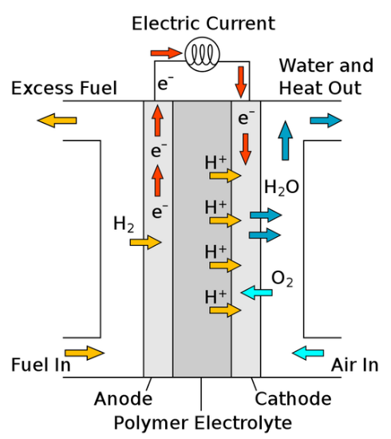](javascript:%20void(0))To produce electricity in a polymer electrolyte membrane fuel cell (PEMFC), a gaseous fuel is input and reacts with a catalyst made of [platinum](javascript:%20void(0)) nanoparticles. When molecular hydrogen comes into contact with this, it splits into two H+ ions and two electrons. The electrons are conducted […] and electricity is produced. The hydrogen ions pass through a proton exchange membrane, the polymer electrolyte where it reaches the cathode and combines with oxygen to form water.

H2 (g) + O2 (g) 🡪 2 H2O (l)

**Figure 1 -** **Polymer electrolyte membrane fuel cell**

From: *https://energyeducation.ca/encyclopedia/Fuel_cell*

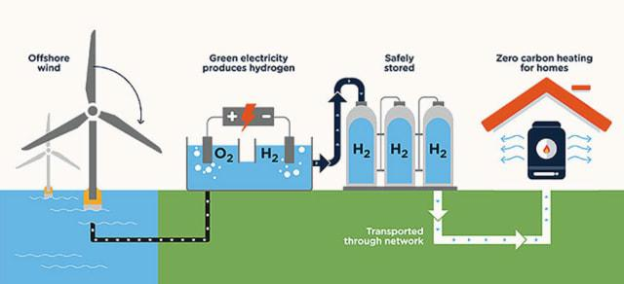**Figure 2 –** **Green hydrogen –** If the electric current is produced by a renewable source (e.g., wind, solar, or hydropower), the hydrogen produced is known as green hydrogen.  
According to the International Energy Agency, less than 0.1% of hydrogen today is produced through the electrolysis of water.

From: [*https://www.eit.edu.au/what-is-green-hydrogen-and-is-it-the-fuel-of-the-future/*](https://www.eit.edu.au/what-is-green-hydrogen-and-is-it-the-fuel-of-the-future/)

1. Present and comment on these documents.
2. Describe how hydrogen cells can store and convert energy ;
3. What do you suggest to produce more green hydrogen ?