**BACCALAURÉAT GÉNÉRAL ET TECHNOLOGIQUE**

**ÉPREUVE ORALE DES SECTIONS EUROPÉENNES ET DE LANGUES ORIENTALES**

|  |  |
| --- | --- |
| **DNL :** physique-chimie | Toutes spécialités |
| **Langue :** Anglais | Voie générale |
| THEME 2: Le futur des énergies | |
| SOUS-THEME : Comment produire durablement l’électricité ? | NOTION : **2.3 Produire durablement de l’électricité** |

**WHAT DOES THE FUTURE OF ENERGY LOOK LIKE ?**

**DOCUMENT 1 – What is Sustainable Energy?**

Sustainable energy is a form of energy that meets today’s demand of energy without putting us in danger of getting expired or depleted and can be used over and over again. Sustainable energy should be widely encouraged as it does not cause any harm to the environment and is available widely free of cost. All renewable energy sources like solar, wind, geothermal, hydropower and ocean energy are sustainable as they are stable and available in plenty. There are many forms of sustainable energy sources that can be incorporated by countries to stop the use of fossil fuels and helps us to reduce greenhouse gas emissions.

*(from the Conserve Energy Futur website – 2022)*

**DOCUMENT 2 – What is ITER?**

ITER ("The Way" in Latin) is one of the most ambitious energy projects in the world today. In southern France, 35 nations are collaborating to build the world's largest tokamak, a magnetic fusion device that has been designed to prove the feasibility of fusion as a large-scale and carbon-free source of energy based on the same principle that powers our Sun and stars without long-lived nuclear waste.

Fusing atoms releases nearly four million times more energy than a chemical reaction such as the burning of coal, oil or gas and four times as much as nuclear fission reactions (at equal mass).

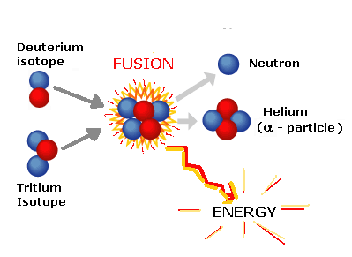

The most efficient fusion reaction in the laboratory is the reaction between two hydrogen isotopes, deuterium (D) and tritium (T). The DT fusion reaction produces the highest energy gain at the "lowest" temperatures.

Einstein's famous formula **E = m.c²** describes the tiny bit of lost mass (m), multiplied by the square of the speed of light (c²), results in a very large figure (E), which is the amount of energy created by a fusion reaction.

*Image 1: Deuterium-tritium DT fusion reaction*

(from the ITER organization website : https://www.iter.org/ *- 2022*)

1. Present and comment on this document.

2. Focus on at least one scientific topic such as the ways to produce sustainable electricity.

3. In your opinion, why is it important for countries to diversify their sources of energy**?**