**BACCALAURÉAT GÉNÉRAL ET TECHNOLOGIQUE**

**ÉPREUVE ORALE DES SECTIONS EUROPÉENNES ET DE LANGUES ORIENTALES**

|  |  |
| --- | --- |
| **DNL :** physique-chimie | Spécialité PC |
| **Langue :** Anglais | Voie générale |
| THÈME 3 : PHYSIQUE ET CHIMIE AU SERVICE DE LA SOCIÉTÉ DU FUTUR | |
| SOUS-THEME : Les ondes au service du citoyen | NOTION : **3.1.3 Propriétés des ondes** |

**HOW DO METEOROLOGISTS USE THE DOPPLER EFFECT?**

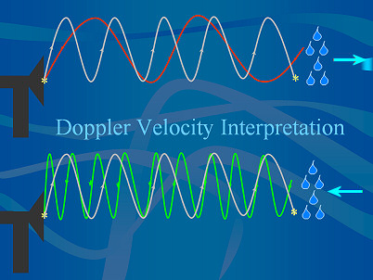**DOCUMENT 1: How does a weather Doppler radar work?**

The basics of radars is that a beam of energy, called radio waves, is emitted from an antenna. As they strike objects in the atmosphere, the energy is scattered in all directions with some of the energy reflected directly back to the radar. The larger the object, the greater the amount of energy that is returned to the radar. That provides us with the ability to "see" rain drops in the atmosphere. In addition, the time it takes for the beam of energy to be transmitted and returned to the radar also provides us with the distance to that object.

*In the image above, the grey line is the transmitted signal. You can see how the returned energy changes its wavelength characteristics when it hits a target moving away or toward the radar (red and green line, respectively)*

.

*https://www.weather.gov/*

*(NOAA : National Oceanic and Atmopheric Administration)*

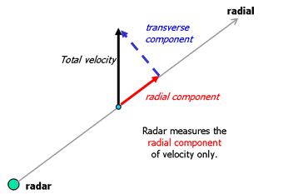**DOCUMENT 2: How does the Doppler Radar Measure Wind speed?**

The wind velocity can be separated into two components known as the radial and transverse components. The radar is only able to sense the motion directly along the radial, either towards or away from the radar, because the transverse component has no effect on the phase of the returning electromagnetic wave. Hence the total wind speed is not measured, only the portion that is directed towards or away from the radar. This is an important concept to understand when interpreting Doppler wind images.

The radial and transverse components of velocity.

*http://www.bom.gov.au/australia/radar/about/doppler_wind_images_intro.shtml*

*(Australian Government – Bureau of Meteorology)*

1. Present and comment on these documents.

2. Focus on at least one scientific topic such as the Doppler effect principle.

3. How impactful are waves in our daily lives?