**BACCALAURÉAT GÉNÉRAL ET TECHNOLOGIQUE**

**ÉPREUVE ORALE DES SECTIONS EUROPÉENNES ET DE LANGUES ORIENTALES**

|  |  |
| --- | --- |
| **DNL :** Physique-chimie | Spécialité PC |
| **Langue :** Anglais | Voie générale |
| THEME 3 : Physique et chimie au service de la société du futur | |
| SOUS-THEME : L’exploration spatiale | NOTION : **3.2.2 satellites et sondes** |

**TWO SATELLITES WILL NARROWLY AVOID COLLIDING AT 32,800 MPH OVER PITTSBURGH**

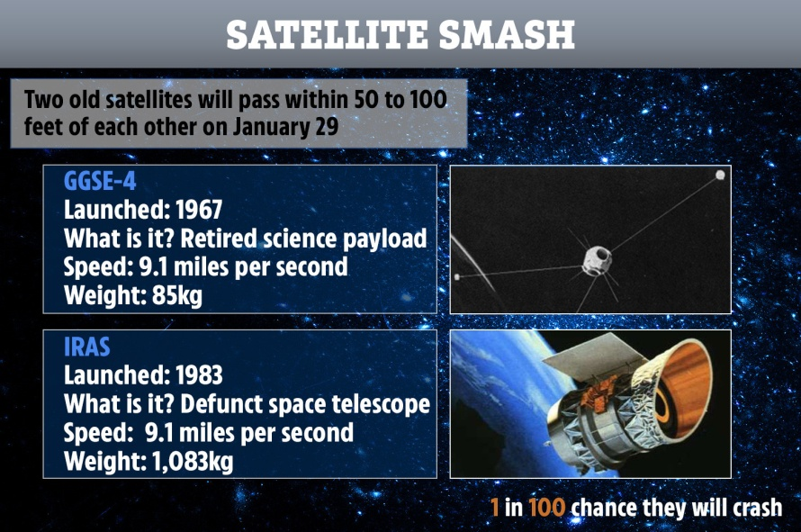Two defunct1 satellites will — hopefully — zip past each other at 32,800 mph (14.7 kilometers per second) in the sky over Pittsburgh on Wednesday evening (Jan. 29, 2020).

When this article was first written Tuesday morning (Jan. 28, 2020) the odds2 of a collision were 1 in 100. A crash has since become five times more likely, with 1 in 20 odds. If the two satellites were to collide, the debris could endanger spacecraft around the planet.

One of the satellites is called the Infrared Astronomical Satellite (IRAS), it was the first infrared space telescope. GGSE-4 was a U.S. Air Force experiment launched to test spacecraft design principles, [according to NASA](https://nssdc.gsfc.nasa.gov/nmc/spacecraft/display.action?id=1967-053C). The two satellites are unlikely to actually slam into3 each other, said LeoLabs* CEO Dan Ceperley. But predictions of the precise movements of fairly small, fast objects over vast distances is a challenge,

If they did collide, "there would be thousands of pieces of new debris that would stay in orbit around the [Earth](https://www.livescience.com/earth.html) for decades," Ceperley said.

*\* LeoLabs was founded in 2016 by scientists and space industry veterans committed to securing low Earth orbit operations. The team is rapidly executing on a global radar network and data services platform to help satellite operators deploy their services safely*

*Source:* By [Rafi Letzter - Staff Writer](https://www.livescience.com/author/rafi-letzter) from " live science "

**1 defunct:** ancient **2 odds:** chances **3 slam into :** s’écraser contre

3 feet ≈ 1 m

1. Present and comment on this document

2. Describe the mechanics laws involved in the motions of satellites.

3. Give your opinion about the necessity to clean up space from old satellites or space debris.