**BACCALAURÉAT GÉNÉRAL ET TECHNOLOGIQUE**

**ÉPREUVE ORALE DES SECTIONS EUROPÉENNES ET DE LANGUES ORIENTALES**

|  |  |
| --- | --- |
| **DNL :** physique-chimie | Toutes spécialités |
| **Langue :** Anglais | Voie générale |
| THEME 3: PHYSIQUE ET CHIMIE AU SERVICE DE LA SOCIETE DU FUTUR | |
| SOUS-THEME : L’exploration spatiale | NOTION : **3.2.3 Intérêts de l’exploration spatiale**- |

**THE ISS: A LABORATORY IN FREE FALL**

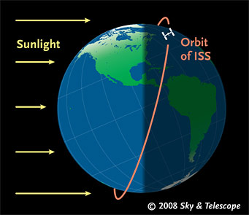**DOCUMENT 1: ISS**

The International Space Station (ISS) is a habitable artificial satellite in low Earth orbit.

Perigee altitude: 418 km

Apogee altitude: 422 km

Orbital speed: 27,600 km/h

Orbital period: 92.68 minutes

**DOCUMENT 2: THOMAS PESQUET**

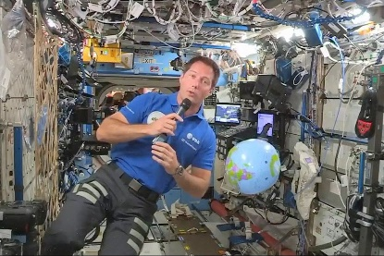ESA astronaut Thomas Pesquet's second mission to the Space Station, known as Alpha, was from April to November 2021. In ‘freefall’ around the planet, astronauts on the Space Station live in microgravity. This ‘weightless’ laboratory offers the opportunity to perform experiments that are just not possible on Earth.

https://www.esa.int/Science_Exploration/Human_and_Robotic_Exploration/Astronauts/Thomas_Pesquet

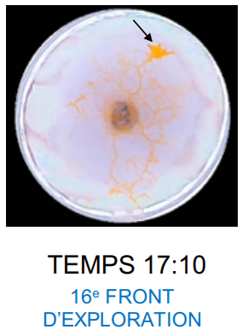**DOCUMENT 3: BLOB experiment**

pseudopod

The Blob is neither plant, nor animal, nor mushroom. Composed of just one cell and without a brain, it is still able to move, feed, organise itself and even transmit knowledge to like-minded slime moulds*.

Thomas Pesquet conducted an experiment on the International Space Station to see how the Blob’s behaviour is affected by microgravity. Students replicated the experiment in their classrooms, to see differences in the Blob’s speed, shape and growth. They noticed that the pseudopods are very reticulated, perhaps more than on Earth, but the exploration strategy is quite the same as the one observed on Earth.

*moulds: moisissures

1. Present and comment on these documents.

2. Focus on the scientific interest of space exploration.

3. How important is it to share scientific knowledge?