**BACCALAURÉAT GÉNÉRAL ET TECHNOLOGIQUE**

**ÉPREUVE ORALE DES SECTIONS EUROPÉENNES ET DE LANGUES ORIENTALES**

|  |  |  |
| --- | --- | --- |
| **DNL :** Physique Chimie | Toutes Spécialités | |
| **Langue :** Anglais | Voie générale | |
| THEME 3: Physique et chimie au service de la société du futur | | |
| SOUS-THEME : Vers une chimie durable | | NOTION : **3.3.3. Vers une eau plus propre** |

**pH AND WATER QUALITY**

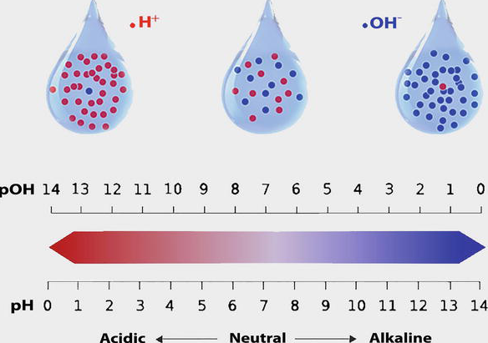pH is one of the most important parameters of water quality. It is a dimensionless number indicating the strength of an acidic or a basic solution. Acidic water contains extra hydrogen ions (H+) and basic water contains extra hydroxyl (OH−) ions. pH ranges from 0 to 14, with 7 being neutral. pH of less than 7 indicates acidity, whereas a pH of greater than 7 indicates a base solution. Carbon dioxide from the atmosphere or from the respiration of aquatic organisms causes acidity when dissolved in water by forming carbonic acid (H2CO3). The level of acidity is determined by titration* with standard sodium hydroxide. Pure water is neutral, with a pH close to 7.0 at 25°C. Normal rainfall has a pH of approximately 5.6 (slightly acidic) owing to atmospheric carbon dioxide gas. Safe ranges of pH for drinking water are from 6.5 to 8.5 for domestic use and living organisms need. Water with pH of 7 is 10 times more acidic than water with a pH of 8, and water with a pH of 5 is 100 times more acidic than water with a pH of 7. Water with very low or high pH is fatal. A pH below 4 or above 10 will kill most fish, and very few animals can endure water with a pH below 3 or above.

*Nayla Hassan Omer -* [*https://www.intechopen.com/*](https://www.intechopen.com/) *- October 16th 2019*

*\*titration : dosage*

1. Present and comment on this document.

2. Focus on the notion of acidity and pH.

3. Do you know other water pollutants and the damage they provoke?