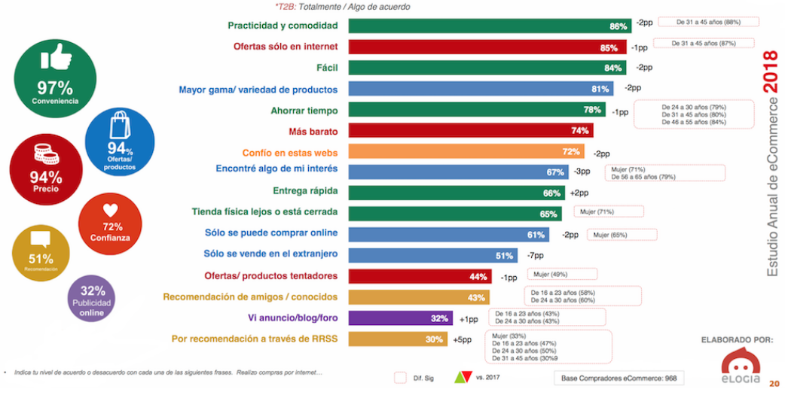
https://www.ecommerceefectivo.com/10-datos-claves-del-ecommerce-en-2018/

