**Niveau : 2nde**

**Science in popular fiction**

**Résumé de l’activité :**

*L’activité s’articule autour de deux extraits vidéos d’un épisode de la série « The Big Bang Theory », où l’un des protagonistes pense avoir découvert une méthode pour synthétiser un nouvel élément superlourd, puis se rend compte d’une erreur de calcul qui remet en cause sa théorie, alors qu’une expérience a effectivement permis de synthétiser le nouvel élément.*

*Cette activité a pour objectif d’entraîner la compréhension orale des élèves, de mobiliser leur expression orale par l’interaction en classe autour des questions et de réaliser un exposé en fin d’activité, d’aborder la constitution des atomes et le tableau périodique d’un point de vue disciplinaire, et d’ouvrir la culture générale des élèves sur différents points (physique théorique vs. expérimentale, cursus universitaire, grandes universités du monde anglophone, unités du système métrique et du système US, sérendipité)*

**Prérequis / repères de progressivité**

*Prérequis : constitution des atomes, numéro atomique.*

## Référence(s) au(x) programme(s)

**Objectifs d’apprentissage en physique chimie / LV**

*Pas d’apprentissage disciplinaire, les notions scientifiques abordées doivent déjà avoir été vues dans les cours en français. Cela permet de se focaliser sur l’apprentissage du vocabulaire scientifique en anglais.*

*L’activité est prétexte à l’apprentissage d’éléments de culture scientifique (théorie vs expérience, unités dans différents systèmes, sérendipité) et de culture générale (monde universitaire)*

**Compétences travaillées (disciplinaires ou linguistique au regard du CECRL) :**

|  |  |
| --- | --- |
| Compétences | Capacités associées |
| APP | Rechercher et extraire l'information (tirer des informations pertinentes à partir de documents, |
| REA | Exploiter ses connaissances autour de la notion d’élément et de la constitution de la classification périodique |
| COM | Formuler une réponse compréhensible (répondre avec des phrases complètes en utilisant un vocabulaire scientifique adapté et rigoureux, des connecteurs logiques (car, donc, si, alors...)) ; structurer un compte-rendu, un argumentaire ou une synthèse |

**Dans le cadre du CECRL, les compétences travaillées sont :**

* **Ecouter**
* **S’exprimer oralement en continu**

**Objectif en termes d’oral**

* *Compréhension orale des vidéos (passées dans un premier temps sans sous-titres, puis avec les sous-titres anglais)*
* *Inciter à la participation orale en classe pour répondre aux questions des activités.*
* *Exposé oral final, par groupes de 2 à 4 élèves (le temps de parole est de 2 minutes environ par élève, donc un groupe de 2 élèves fait un exposé de 4 minutes, un groupe de 3 élèves 6 minutes…)*
* *Pour inciter l’ensemble du groupe à être actif pendant la phase des exposés, à la fin de chaque présentation par un groupe d’élève, les autres élèves sont invités à poser des questions avant que le professeur n’intervienne dans la discussion.*

**Document élève**

L’activité est scindée en 2 parties, dans un premier temps seule la partie 1 est distribuée, la partie 2 n’est donnée qu’après avoir répondu à toutes les questions de la partie 1.

**Science in popular fiction**

**Part 1. Video 1. (**[**https://www.youtube.com/watch?v=44slJj34qWo**](https://www.youtube.com/watch?v=44slJj34qWo)**)**

**Questions:**

1. What are the names of the two world-known scientists in the video? What are their areas of research?
2. To what family of transformations do the equations on the left side of the board correspond? What is the meaning of the numbers next to the symbols of the elements?
3. With the help of a periodic table, can you tell what the elements Pu, Cm, Md have in common? What is the origin of the name of those three elements?
4. Some symbols for the elements are now outdated (even if the video dates back only to 2013). For the elements Uup, Uus and Uuo, the sum of the numbers in superscript in the equations on the right side of the board are linked to the number of protons in their nucleus. The symbol Lv is correct and can be found in the actual periodic table.

With this information, and with the help of a periodic table, try to identify the new symbols and names of elements Uup, Uus and Uuo.

1. What is the number of protons in the nucleus of the element named Ubn on the board? Can you find this element in the periodic table?
2. What is the tallest scientist so happy about? Has his achievement been made by real-life scientists?

Bonus: where do these scientists live? In which university do they work? Can you name other universities or colleges in the US and the UK?

**Part 2. Video 2. (**[**https://www.youtube.com/watch?v=hktk-xyCCyY&list=RDhktk-xyCCyY**](https://www.youtube.com/watch?v=hktk-xyCCyY&list=RDhktk-xyCCyY)**)**

**Questions:**

1. What is the name of the woman in the video? What is her area of research? Is it a real science?
2. All the characters who appeared in both videos are doctors. Explain what the title “doctor” means.
3. What is the book the male scientist is holding? What is its use?
4. The woman states that “Americans can’t handle the metric system”. What is the metric system? What system do the Americans use? Search on the Internet some units in both systems for distances, liquid volumes, masses and temperature. What do you think about the practicality of each system?
5. Find on the Internet an example of a real-life fact where a mistake between metric system and American units had a dramatic consequence.
6. A discovery that has been made through some blunder or by chance is called a serendipitous discovery. For next time, find a serendipitous discovery in science and present the history of this discovery to the class (you will work by groups of two to four people for this item, you can prepare a slideshow if you want, and your presentation of the discovery should last about 2 minutes for each person in the group: 4 minutes for 2 pupils; 6 minutes for 3 pupils; 8 minutes for 4 pupils).

**Document professeur**

Cette activité dure environ 4 séances d’1h pour les réponses aux questions, puis 2-3 séances supplémentaires pour les exposés selon le nombre d’élèves.

Il est possible d’étudier le tableau dans la vidéo en mettant sur pause au bon moment, mais certains symboles sont difficiles à étudier. L’image ci-dessous reproduit les inscriptions du tableau :



Corrigé de l’activité :

Part 1:

1. The names of the two scientists in the video are Leonard Hofstadter (the one with glasses) and Sheldon Cooper (the tall one), from the TV show “The Big Bang Theory”. Sheldon is a theoretical physicist, he develops new theories in physics and the mathematics to support those theories. Leonard is an experimental physicist, who performs actual experiments, sometimes to prove or disprove a new theory elaborated by theoretical physicists.
2. The equations on the left side of the board correspond to nuclear transformations. The number at the bottom next to the symbol of an element is the atomic number of the element, which corresponds to the number of protons in the nucleus. The number at the top next to the symbol of an element is the number of mass, which corresponds to the number of nucleons (protons + neutrons) in the nucleus.
3. The elements Pu, Cm, Md are all synthetic elements, they don’t exist in nature (except for trace amounts of Pu in uranium ores) and have been synthesized in laboratories. Pu is Plutonium, named after the dwarf planet Pluto, as it follows Uranium and Neptunium in the periodic table. Cm is Curium, named in honor of Marie and Pierre Curie, two French physicist who studied radioactivity and discovered the elements Radium and Polonium. Md is Mendelevium, named in honor of Dmitri Mendeleiev who is considered as the father of the periodic table.
4. Uup is now refered to as Mc (Moscovium), Uus is now Ts (Tenessine) and Uuo is Og (Oganesson).
5. The element named Ubn on the board has 120 protons. It doesn’t exist in current periodic tables.
6. The tallest scientist (Sheldon) thinks he discovered a new method to synthesize new superheavy elements (elements that are not yet in the periodic table, with atomic numbers greater than 118). No real-life scientist managed to synthesize these elements yet.

Bonus: The two scientist live in Pasadena, California, USA (near Los Angeles). They work at Caltech (California Institute of Technology) which is located in Pasadena.

Here are a few other famous Universities or Colleges in the US (you can place them approximately on a map with your pupils): Berkeley and Stanford (both in or near San Francisco, California); UCLA (University of California Los Angeles); MIT (Massachusetts Institute of Technology) and Harvard (both located in Cambridge, Massachusetts, near Boston); Yale (in New Haven, Connecticut, between New York and Boston); Princeton (In Princeton, New jersey); University of Pennsylvania (Philadelphia, Pennsylvania)…

All the Universities mentioned above are private universities, but there are also famous public universities in the US, for instance the State Universities such as the Pennsylvania State University (often abbreviated “Penn State”, with various campuses located all over Pennsylvania); Washington State University (in the State of Washington, near Seattle on the West Coast of the USA, not in the city of Washington)…

In the UK, the two most famous Universities are Oxford and Cambridge, but there is also the Imperial College in London, the University of Edimburgh…

Part 2:

1. The name of the woman is Dr. Amy Farah Fowler, she is a neurobiologist (she does research about what happens in brains, her area is biology). Of course it is a real science, but it is a running gag in the show that Sheldon considers all other areas except physics as not real sciences.
2. In academia, a “doctor” is someone who obtained a doctorate. It is the highest University degree. To obtain it, one has do write and defend a thesis which sums up a few years of research. In most countries, the academic degrees are Bachelor (or Licence, three years after A-level), Master (5 years after A-level) and Doctor (in France, usually 4 to 5 years after the Masters degree; in the US, in average 7 years after the Masters degree but sometimes more than 10 years).
3. Sheldon is holding a Handbook of Chemistry and Physics. It is a kind of dictionary of physics and chemistry, which gives plenty of information about elements, molecules, reactions and their names and properties. It was very useful for chemists and physicists especially before the internet.
4. The metric system is the system of units based on the meter, the one used in France. Americans usually use the United States Customary System. Here are some examples of the units they use, their conversions between them and with metric system units :

|  |  |  |
| --- | --- | --- |
|  | Metric units | US units |
| Distances | Meter (m)  Millimeter (mm)  Kilometer (km)  … | Inch (1 in = 25.4 mm)  Foot (1 ft = 12 in = 0.30 m)  Yard (1 yd = 3 ft = 0.91 m)  Mile (1 mi = 1760 yd = 1.6 km) |
| Mass | Gram (g)  Kilogram (kg)  Milligram (mg)  Ton = 1000 kg … | Ounce (1 oz = 28.3 g)  Pound (symbol lb ; 1 lb = 16 oz = 454 g)  Ton = 2000 lb = 907 kg |
| Fluid volumes | Liter (L)  Milliliter (mL)  … | Fluid ounce (1 fl oz = 29.57 mL)  Pint (1 pt = 16 fl oz = 568 mL)  Gallon (1 gal = 3.79 L) |
| Temperature | Celsius degree (° C)  0 °C = melting ice  100 °C = boiling water | Farenheit degree (° F)  0 °F = temperature of a 50-50 mixture of salt and water ice  100 °F = blood temperature of a horse  °F = (9/5)× °C + 32 |

As you can see, the logic in the US units is quite complicated to understand, and the conversion factors are strange (× 3 ; × 12 ; × 16) to convert from one US unit to another. Even the definitions of these units are complicated (see °F).

1. Because of a mistake in the units systems, a 200-million dollar probe (named Mars Climate Orbiter) was destroyed in Mars’s atmosphere instead of orbiting the planet… One software measuring the altitude of the probe was using one system of unit, and another software correcting the speed of the probe so that it was at the right altitude used the other system of units. As a result, the second software thought the probe was about 226 km from the surface while it was actually at only 57 km from the surface… The probe was destroyed by burning in the atmosphere of the planet at this altitude. (see picture below)

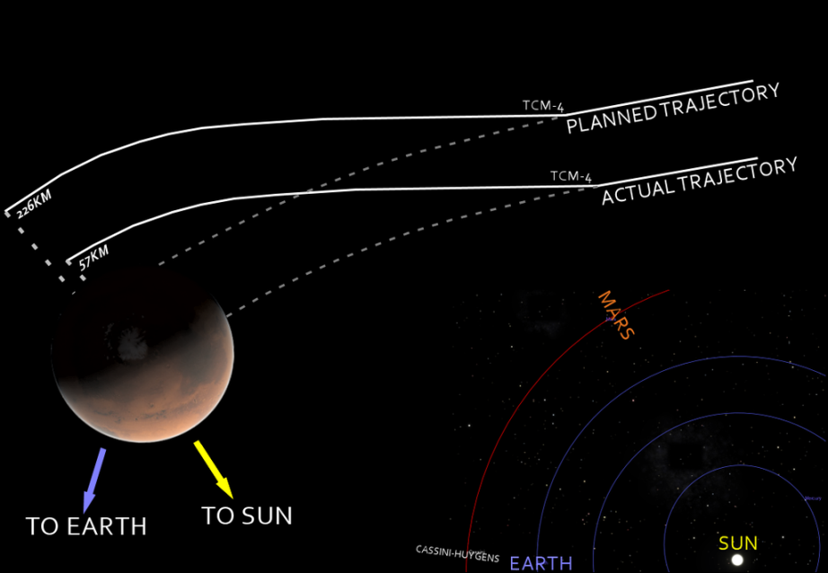

1. Presentation of serendipitous discoveries by groups of pupils. If the pupils don’t find ideas, here are a few: the micro-wave oven; penicillin; conductive polymers; the Post-It note; Velcro; rubber vulcanization; discovery of color blindness; Coca-Cola; Super-Glue; aspartame; saccharine…

Commentaires : les différentes questions sur la culture générale peuvent entraîner la discussion hors du cadre de la correction proposée (unités dans différents systèmes, autres Universités que celles mentionnées, digression sur les formations académiques…)