BACCALAURÉAT GÉNÉRAL ET TECHNOLOGIQUE
ÉPREUVE ORALE DES SECTIONS EUROPÉENNES ET DE LANGUES ORIENTALES
DNL : physique-chimie | Fiche candidat
Langue : ANGLAIS | Voie générale
THEME : Le futur des energies
SOUS-THEME : Les atouts de l’électricité | NOTION : 2.2.1 Produire de l’énergie électrique

HOW DO BATTERIES WORK?
DOCUMENT 1:
Batteries consist of one or more electrochemical cells that store chemical energy for later conversion to electrical energy. Batteries are used in many day-to-day devices such as cellular phones, laptop computers, clocks, and cars.
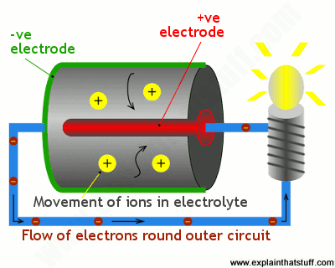
The positive and negative electrodes are separated by the chemical electrolyte. It can be a liquid, but in an ordinary battery it is more likely to be a dry powder. The electrons and ions flow because of the chemical reactions happening inside the battery—usually two of them going on simultaneously. The exact reactions depend on the materials from which the electrodes and electrolyte are made.

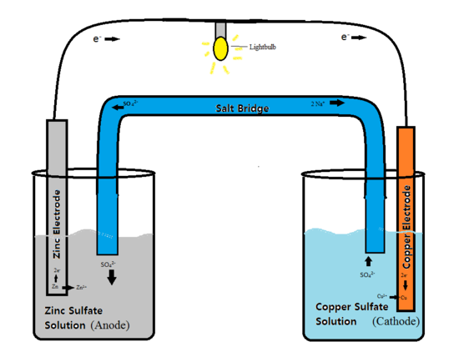
DOCUMENT 3: Daniell cells

DOCUMENT 2: Wet battery in automobile
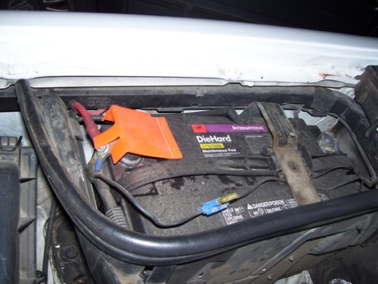
The lead-acid cells in automobile batteries are wet cells. Wet cell batteries contain a liquid electrolyte. Due to the liquid nature of wet cells, insulator sheets are used to separate the anode and the cathode. Types of wet cells include Daniell cells among others. Batteries vary both in size and voltage due to the chemical properties and contents within the cell.
https://chem.libretexts.org

DOCUMENT 4: Lead-acid cells

1. Present and comment on these documents.
2. Do not forget to focus on at least one scientific topic.
3. In your opinion, what are the environmental concerns related to the widespread use of batteries?

