BACCALAURÉAT GÉNÉRAL ET TECHNOLOGIQUE
ÉPREUVE ORALE DES SECTIONS EUROPÉENNES ET DE LANGUES ORIENTALES
DNL : physique-chimie | Fiche candidat
Langue : ANGLAIS | Voie générale
THEME : LE FUTUR DES ENERGIES
SOUS-THEME : Les atouts de l’électricité | NOTION : 2.2.3 Nécessité de stockage

Examples of energy storage
DOCUMENT 1: Energy Storage
The electricity grid is a complex system in which power supply and demand must be equal at any given moment. Historically, supply has been adjusted to meet changes in demand, from the daily patterns of human activity to unexpected changes such as equipment overloads, wildfires, storms, and other extreme weather events. Now, we also look to flexibility in electricity demand to help optimize use of renewables, from how we heat and cool our homes to when we charge electric vehicles. Energy storage plays an important role in this balancing act and helps to create a more flexible and reliable grid system.
For example, when there is more supply than demand, such as during the night when continuously operating power plants provide firm electricity or in the middle of the day when the sun is shining brightest, the excess electricity generation can be used to charge storage devices. When demand is greater than supply, storage facilities—even those in individuals’ homes—can discharge their stored energy to the grid.
https://www.ucsusa.org, Union of Concerned Scientists
DOCUMENT 2: Energy Storage Devices
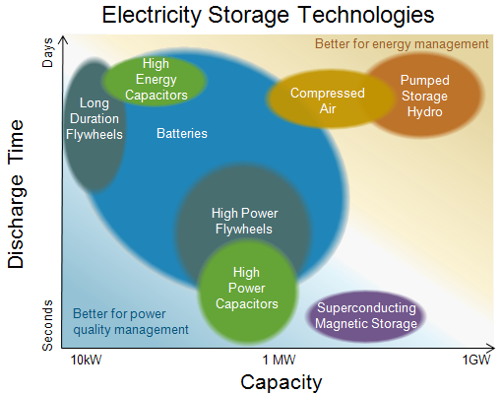

1. Present and comment on these documents.
2. Do not forget to focus on at least one scientific topic.
3. To what extent has energy production and consumption become a challenge nowadays?

