ATOM HISTORY

- Oral presentation of your poster
- Thanks to the oral presentation of your classmates, fill in the following table
 | Democritus | Dalton | Thomson | Rutherford | Bohr | Schrodinger
Nationality | Greek physicist(scientist) | english | english | British New- Zealander | Danish
Birth and death | -460 BC/ -370 BC | 1766 - 1844 | December 1856-1940 | 1871-1937 | 1885-1962
Atomic model’s date | -442 BC | 1803 | 1904 | 1911 | 1913
Nickname of the model |  | Billiard ball model | Plum pudding model | Planetary model | Energy level model
Representation of the model  (paste the images below) |  | 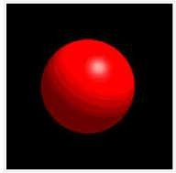 | 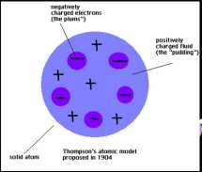 | 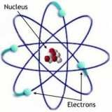 | 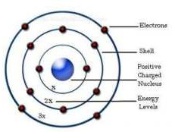
More information | The atom is indivisible | He announced (stated) the law of multiple proportions  He was colorblind (He suffered from colorblindness and discovered it) | It is dense and all the particles are mixed inside the atom | The atom is composed of 2 parts. One part is the nucleus . The 2nd one is made of electrons as  planets around the Sun. | He discovered the energy levels called “shells”.  He thought electrons were fixed on their circular orbits.

Images to cut and paste
