ATOM HISTORY EVALUATION
CANDY MODEL?
Each of the models previously studied has a matching "candy model" (see list and pictures of candies below).
Can you figure out which "candy model" best represents

- Democritus' model of the atom?
- Dalton's model of the atom?
- Thomson's model of the atom?
- Rutherford's model of the atom?
- Bohr's model of the atom?
- the Modern Quantum Mechanical Model of the atom?

- Fill in the following table
- Provide EVIDENCE and EXPLANATIONS for why each of the "candy models" you pick best matches the "real models." Don’t forget to use as much as you can the scientific vocabulary studied.Record yourself individually.
Candy model | 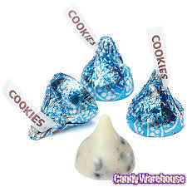  Hershey's Cookies N' Cream Kiss combine the sweet flavor of white chocolate with real pieces of cookie | 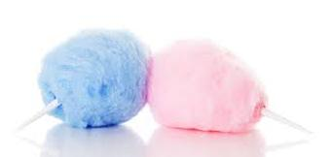  Cotton Candy | 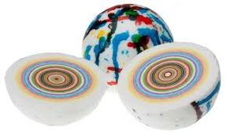  Gobstopper consist of a number of layers, each layer dissolving to reveal a different colored (and sometimes differently flavored) layer, before dissolving completely
Matching Model of the atom
Candy model | 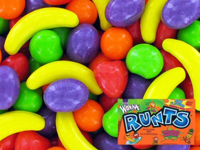  Runts hard candies (orange, banana, grape, apple, strawberry) | 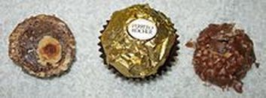  Ferrero Rocher the chocolate candy consists of a whole roasted hazelnut encased in a thin wafer shell filled with hazelnut cream and covered in milk chocolate and chopped hazelnuts. | 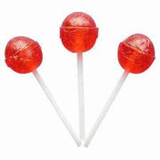  Cherry Lollipop (no special center - hard all the way through)
Matching Model of the atom

NOTES | Evaluation Présentation ELEVES:
Prononciation (2)
Grammaire/vocabulaire scientifique(4)
Fluidité (4)
TOTAL sur 10

